Final Project On Consumption Pattern Of Water
And
Its Future Consumption – New York

Sartaj Babra, Vidhi Tripathi, Saiyam Shah, Yue MA
Algonquin College
Data Visualization

Professor: Prableen Singh
Submission Date:

Table of Contents
- Executive Summary… ……………………………………………………..........3
- Background………………………………………………………………………4
- Analysis………………………………………………………………………….5
- Conclusion and recommendations……………………………………………….6
- References……………………………………………………………………….9

Executive Summary:
The future consumption of water is a lot dependent upon type user whether he/she belongs to a general population, or the user is from industries such as healthcare, hospitality, retail etc.
When it comes to the consumption amongst city people users the consumption has dropped significantly over the last 20-year, similar trend could be seen in the hotels sectors where the consumption dropped but when we further deep dive into the different type of industries, the consumption varies a lot.
And if we look forward to future consumption behavior the pattern varies from user to user and this report could help to focus on the particular user who is using water the most.

Background:
It is generally observed that the water consumption is increasing with growth in the population, increase in the number of hotels, industries, commercial buildings and many more. This hypothesis is completely fine as per general understating. However, it is always suggested to review the analysis report before making any conclusion. This report will focus on, how has the consumption changed with growth in the population, increase in the number of hotels and other industries such as commercial, retail, banking etc.
Date Collection and Preparation
Collection of Data
Data was collect from the state’s official government websites
- New York
  - https://opendata.cityofnewyork.us/
  - https://energy.cusp.nyu.edu/#/
Preparation:
Basic check and cleaning were done to avoid any skewness/distraction in the data.
  - Duplicate
  - Missing value
  - Outlier etc.

Analysis
- Overall cost, per day cost and person cost were calculated using the basic data points, which helped to gain additional insights on the cost of consumption.
- Average Analysis: The average score of 5 years from 2006 -2020 was calculated for each user to understand the past years trend, which could help us to develop the hypothesis what will happen in future.
- Forecasting: The forecasting tool was used to cross check the analysis which help to make the prediction to be confident at 99% confidence.

Dashboard
- Homepage that would help to navigate us to different Dashboard
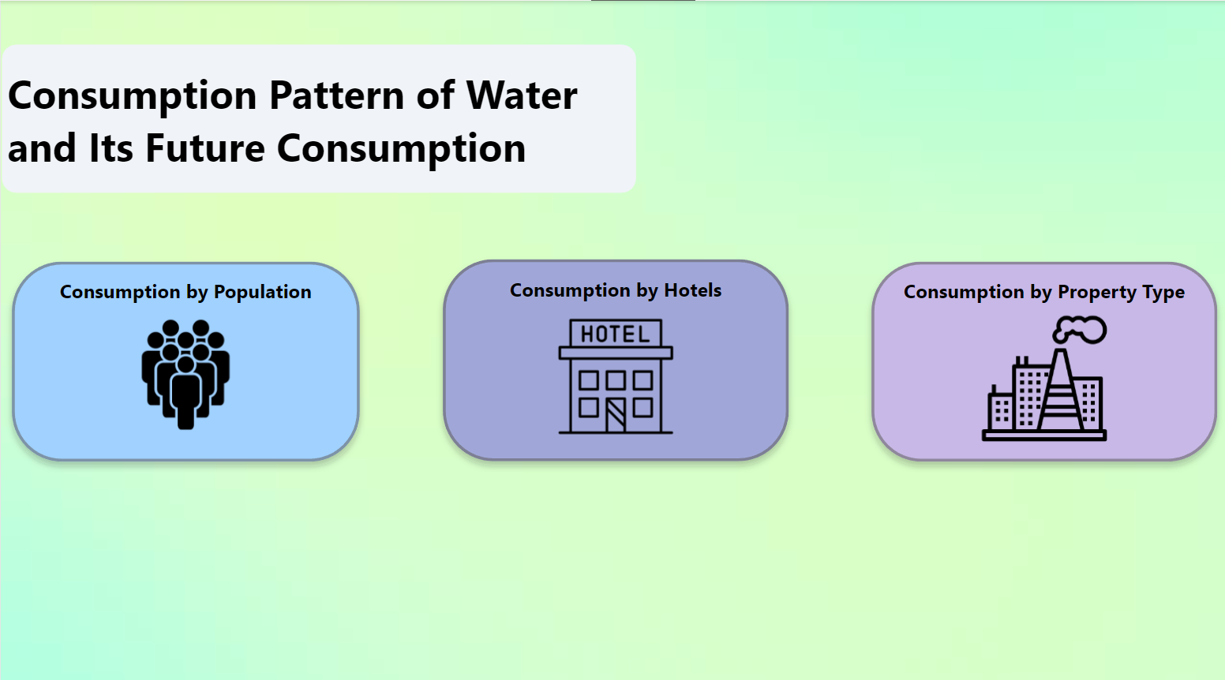
- Population/peoples dashboard giving us the information on water consumption and cost usage from year 2000-2020
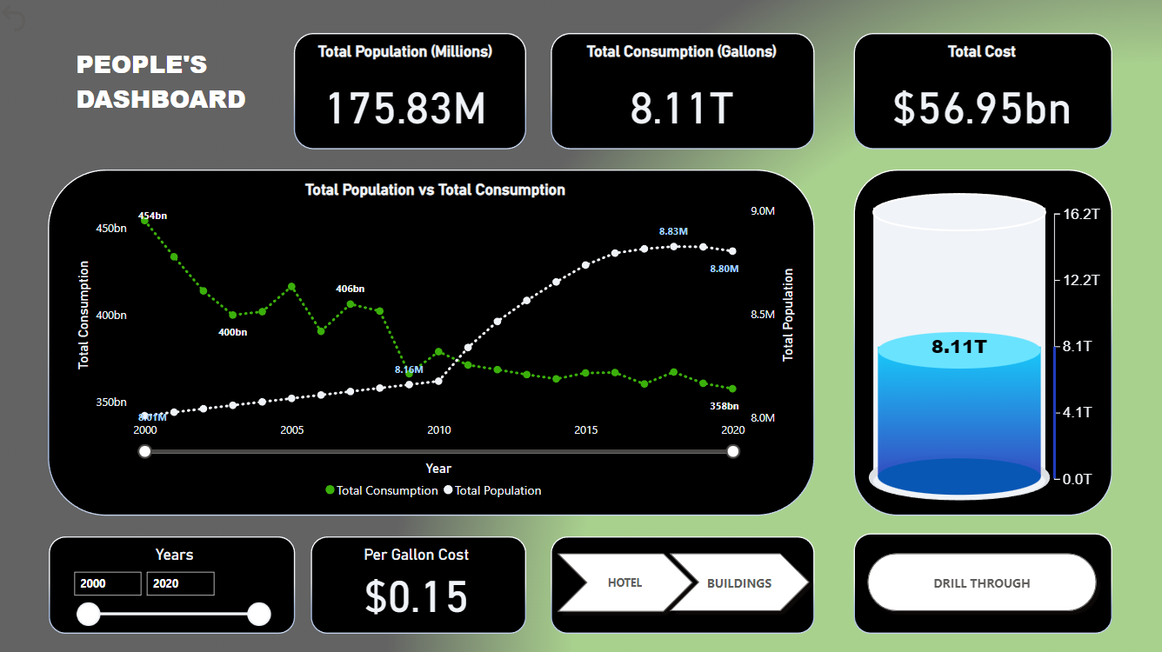

- Drill through on increase in population and consumption
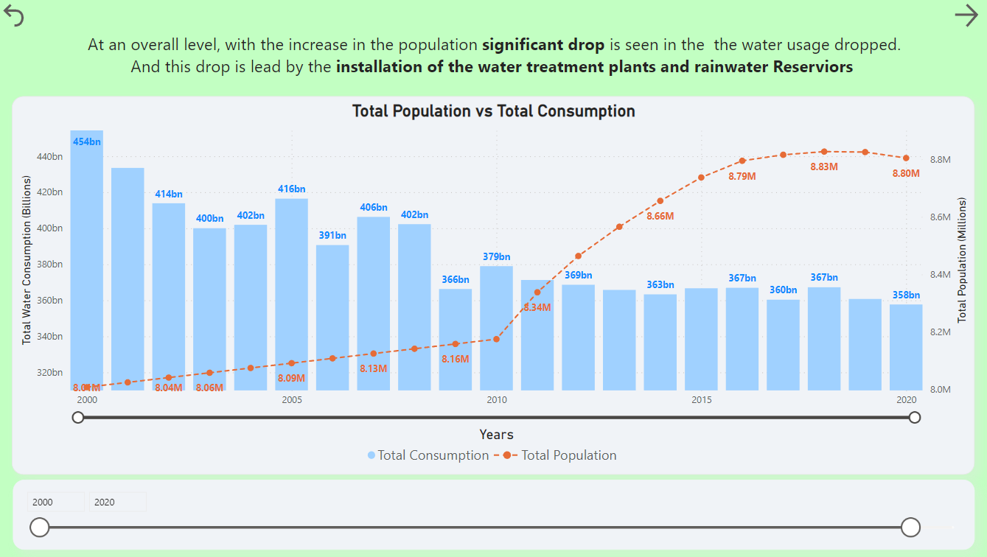

- How are cost and consumption related to each other?

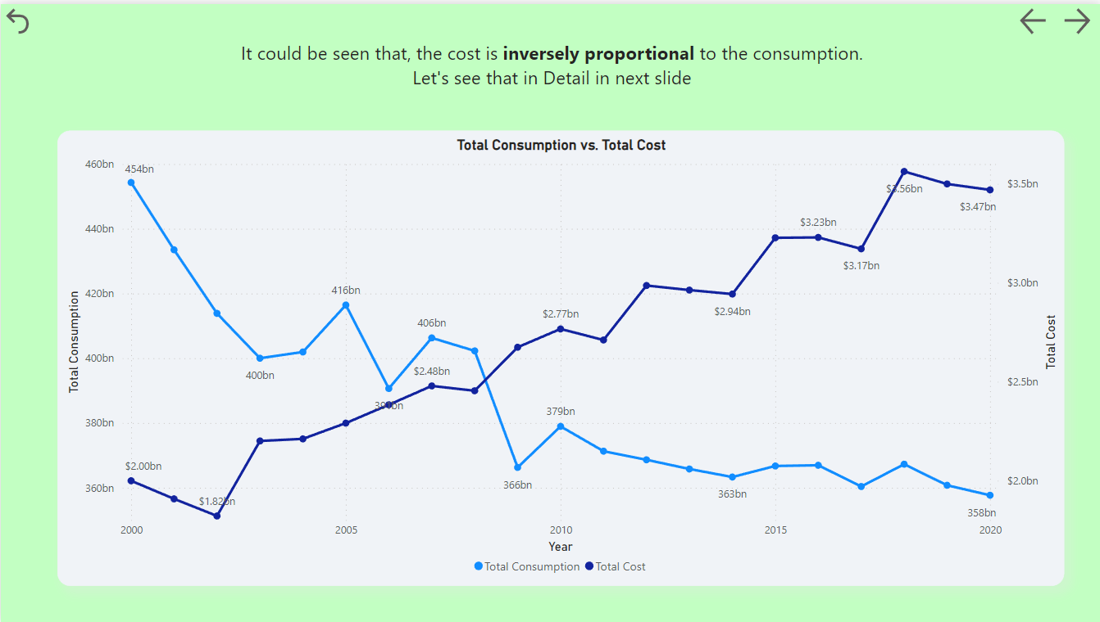
- What was total consumption and cost spent each year?
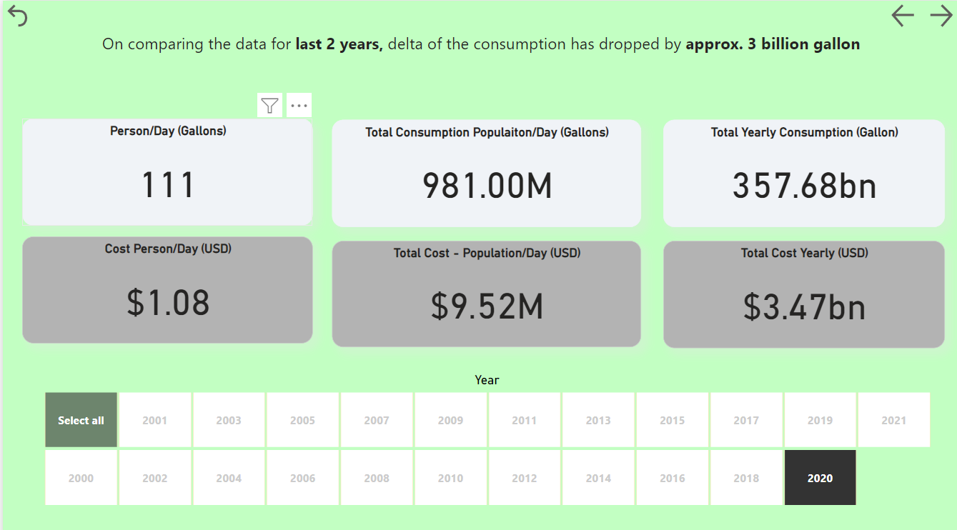
- Understanding the past trends of consumption and cost
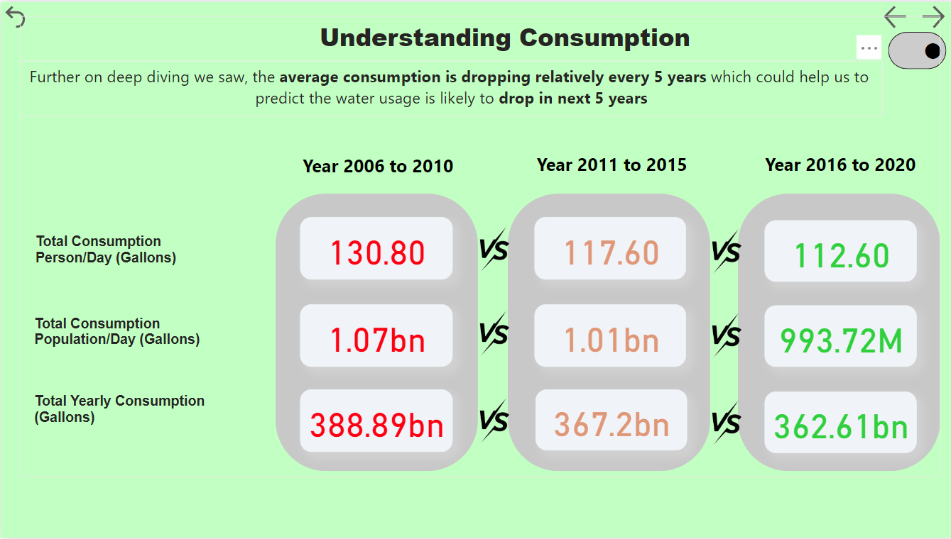

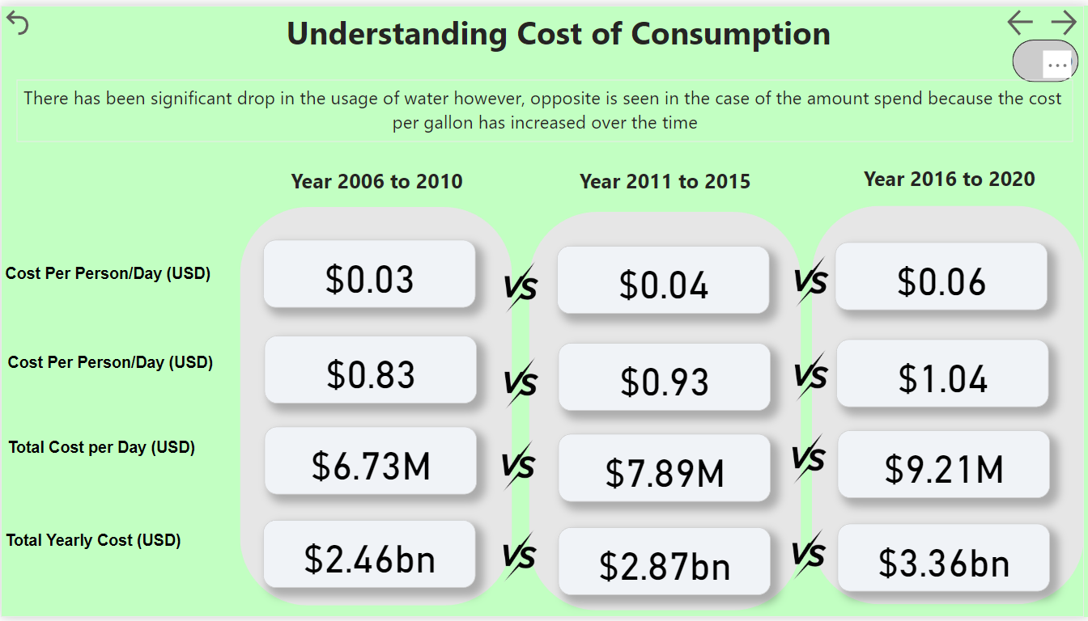
Future Prediction
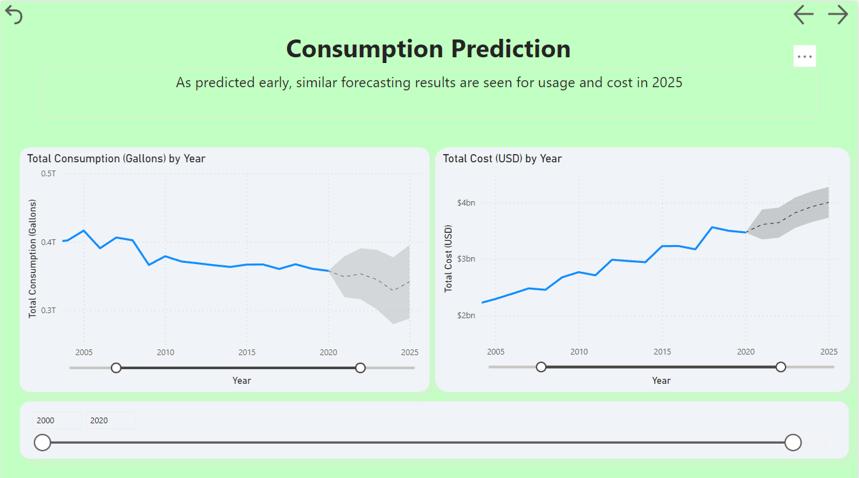

Hotels Dashboard
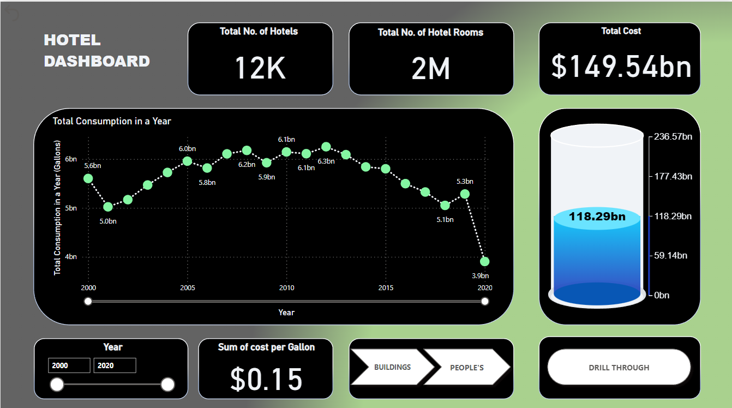
- Relation between the consumption, cost and number of hotels
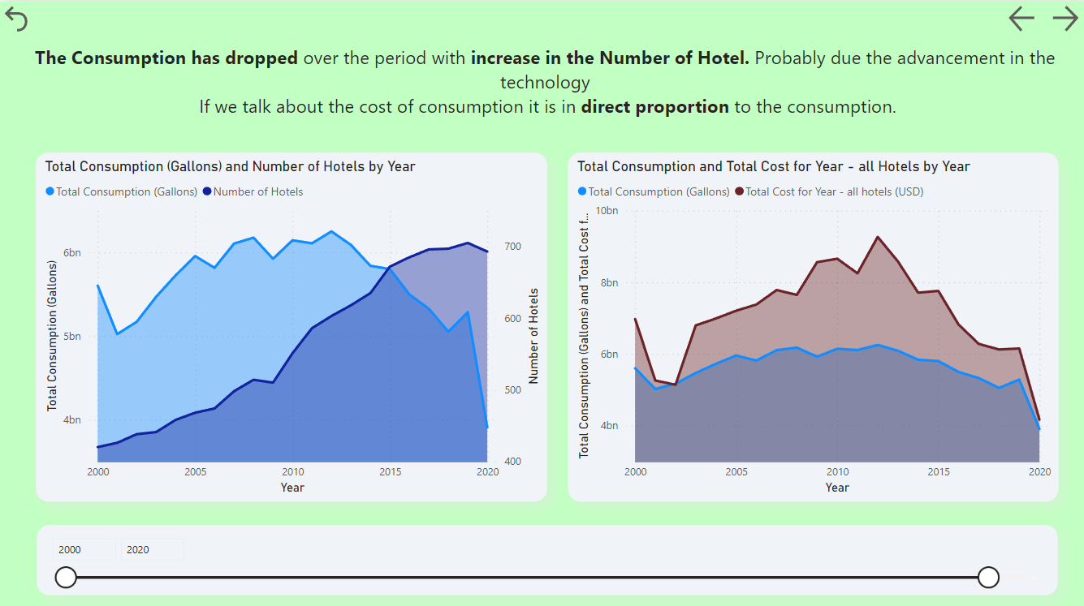

- Average analysis for the consumption and cost
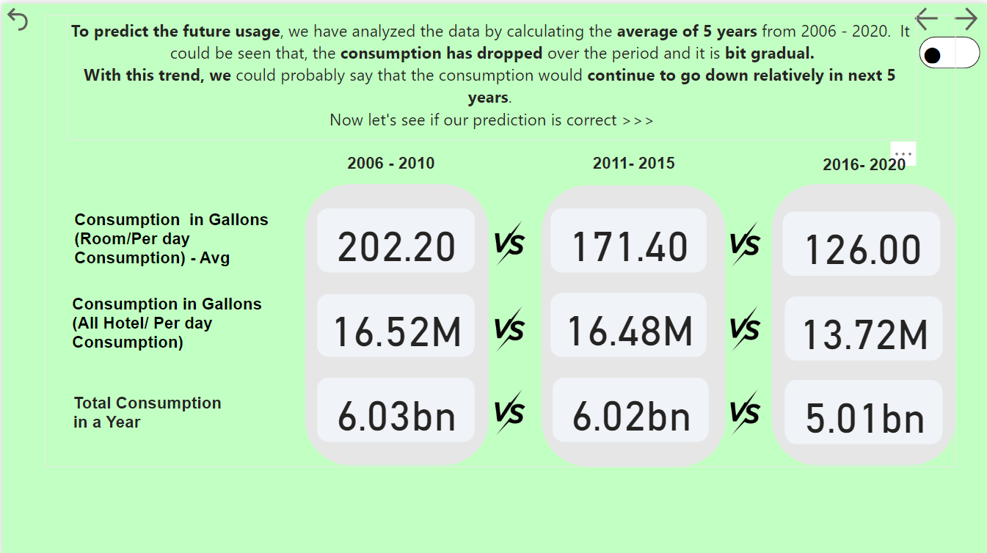
- Future prediction
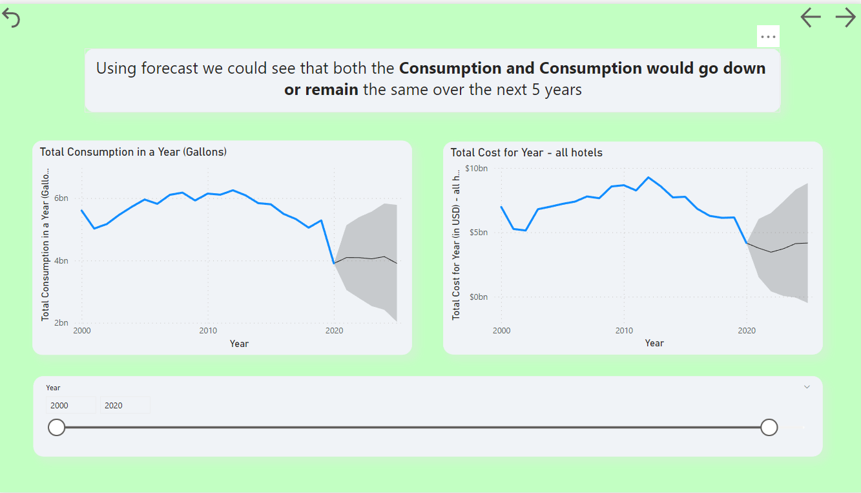
Industry/building type dashboard
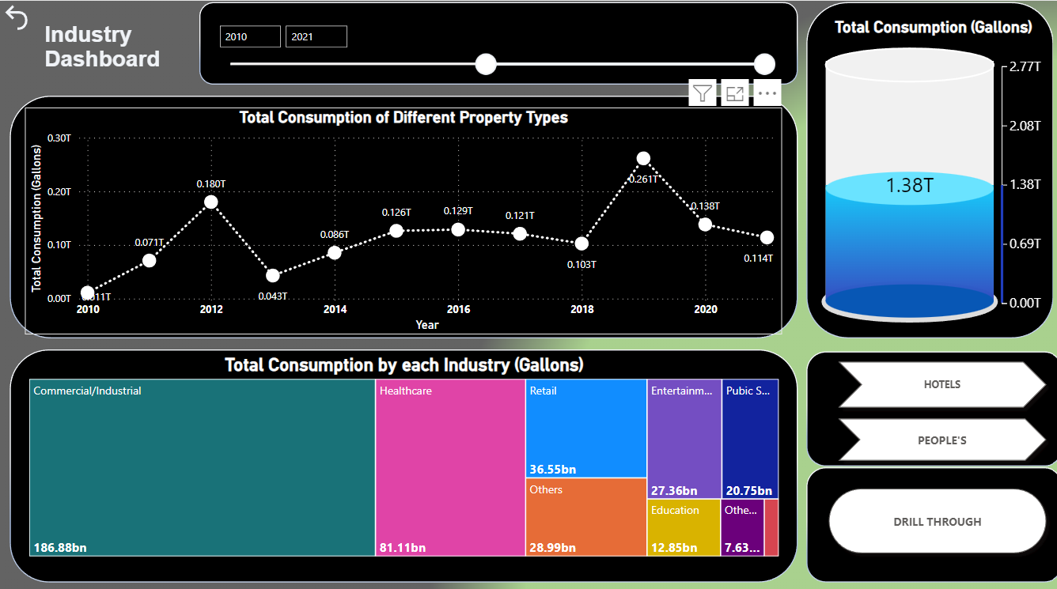
- Consumption amongst different sectors over the last 10 years
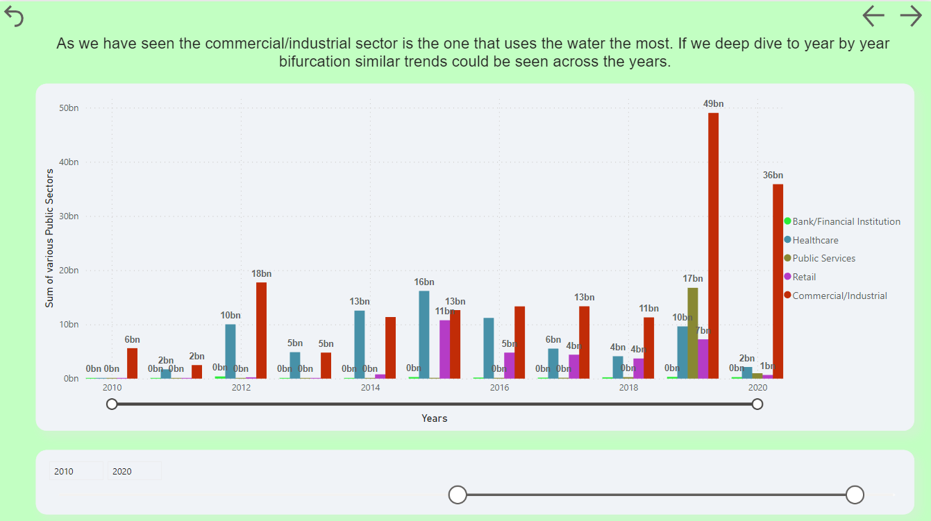
- Average analysis:
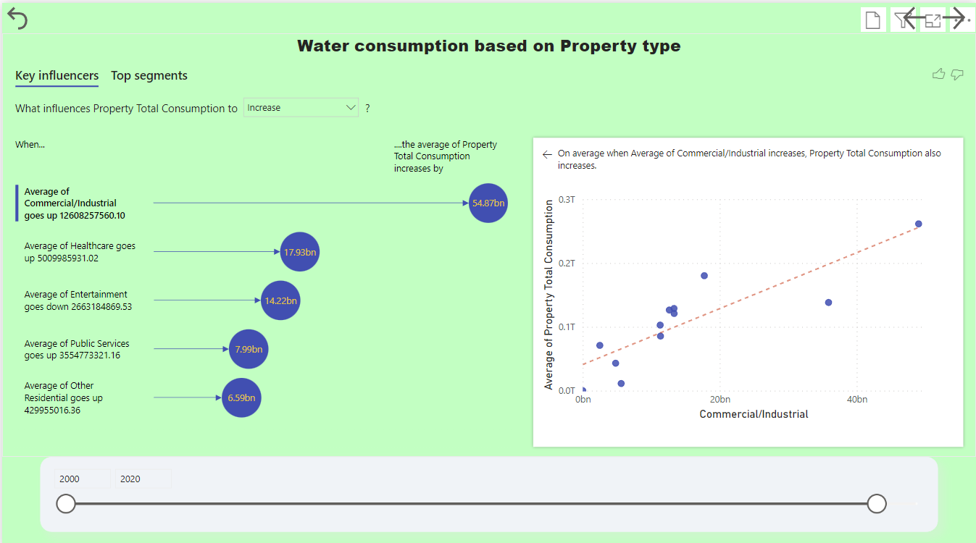

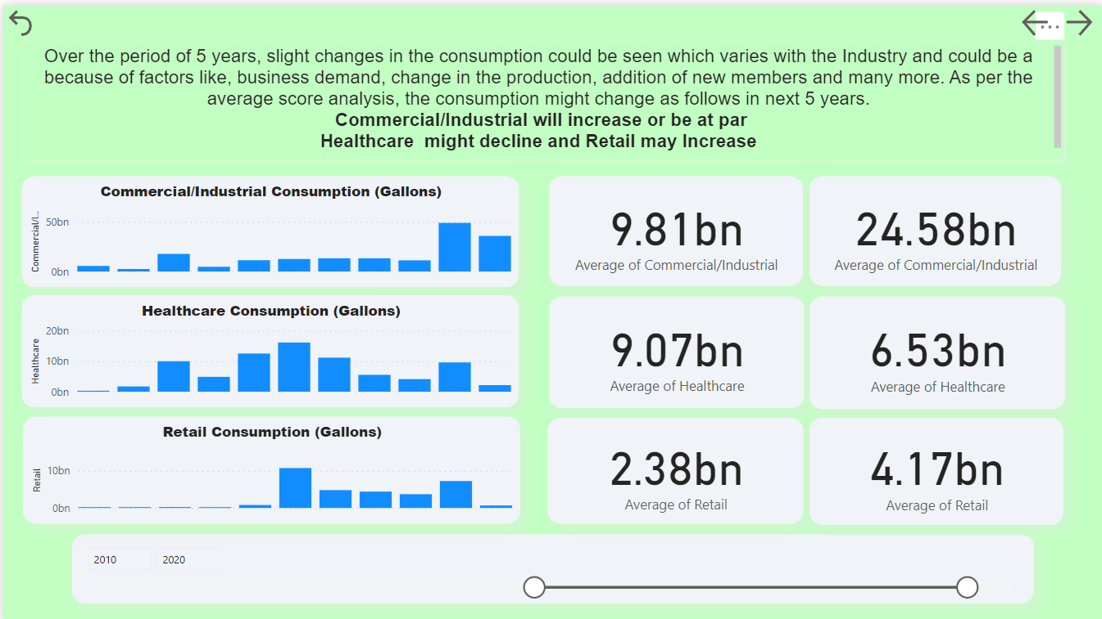
Future Prediction:
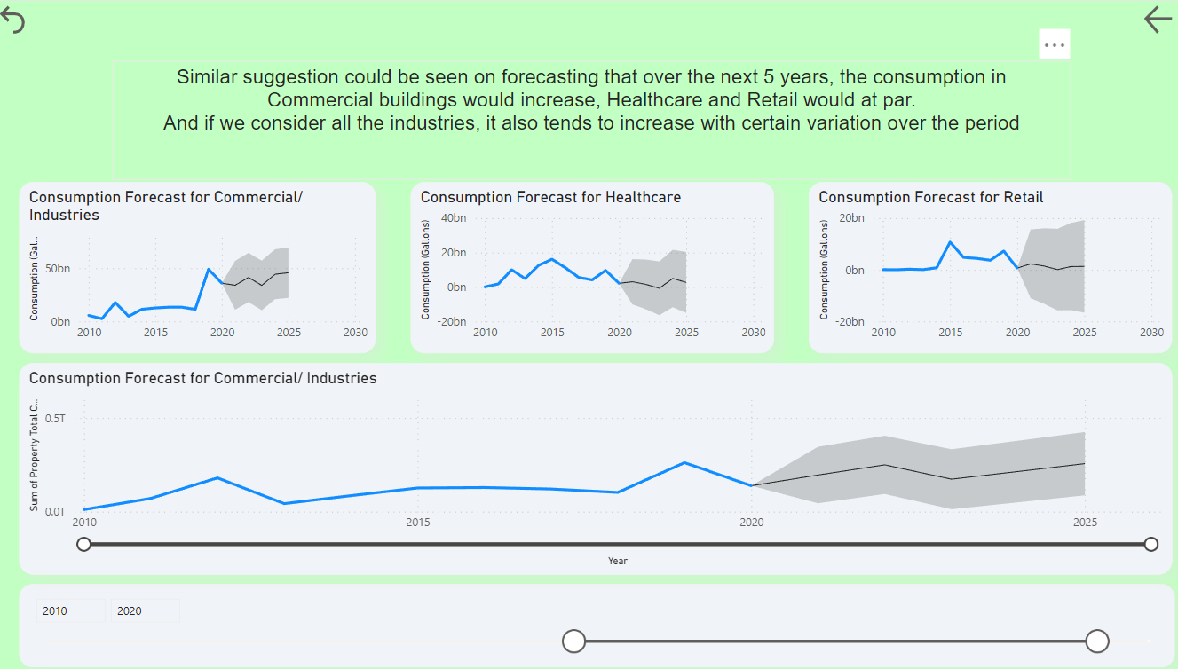

Conclusions and recommendations:
Population:
- Increase in the population do not have negative impact on the consumption of the water because of the advancement of the technology and awareness to save water.
- In the coming 5 year, the consumption would continue to go down.
Hotel
- Similar case is seen in hotel water consumption, with the increase in the number of hotels the consumption is going down and would continue to drop in the coming years.
- Except year 2020, the drop in the consumption could be again for the same reason.
Industry Type
- The consumption would vairy from Industry to Industry and demand in the water requirement. As per the current scenario.
  - The commercial/Industry would likely to increase significantly.
  - Healthcare to drop gradually and Retail to increase slightly.

References:
- Open Data NYC. [Online]. Available: https://opendata.cityofnewyork.us/.
- NYU Center for Urban Science and Progress. [Online]. Available: https://energy.cusp.nyu.edu/#/

